EPRI OpenESB Mediator
Building a TestHarness Service Tutorial

1023648
Final Report, January 2017

DISCLAIMER OF WARRANTIES AND LIMITATION OF LIABILITIES
THIS DOCUMENT WAS PREPARED BY THE ORGANIZATION(S) NAMED BELOW AS AN ACCOUNT OF WORK SPONSORED OR COSPONSORED BY THE ELECTRIC POWER RESEARCH INSTITUTE, INC. (EPRI). NEITHER EPRI, ANY MEMBER OF EPRI, ANY COSPONSOR, THE ORGANIZATION(S) BELOW, NOR ANY PERSON ACTING ON BEHALF OF ANY OF THEM:
(A) MAKES ANY WARRANTY OR REPRESENTATION WHATSOEVER, EXPRESS OR IMPLIED, (I) WITH RESPECT TO THE USE OF ANY INFORMATION, APPARATUS, METHOD, PROCESS, OR SIMILAR ITEM DISCLOSED IN THIS DOCUMENT, INCLUDING MERCHANTABILITY AND FITNESS FOR A PARTICULAR PURPOSE, OR (II) THAT SUCH USE DOES NOT INFRINGE ON OR INTERFERE WITH PRIVATELY OWNED RIGHTS, INCLUDING ANY PARTY'S INTELLECTUAL PROPERTY, OR (III) THAT THIS DOCUMENT IS SUITABLE TO ANY PARTICULAR USER'S CIRCUMSTANCE; OR
(B) ASSUMES RESPONSIBILITY FOR ANY DAMAGES OR OTHER LIABILITY WHATSOEVER (INCLUDING ANY CONSEQUENTIAL DAMAGES, EVEN IF EPRI OR ANY EPRI REPRESENTATIVE HAS BEEN ADVISED OF THE POSSIBILITY OF SUCH DAMAGES) RESULTING FROM YOUR SELECTION OR USE OF THIS DOCUMENT OR ANY INFORMATION, APPARATUS, METHOD, PROCESS, OR SIMILAR ITEM DISCLOSED IN THIS DOCUMENT.
The following organization(s), under contract to EPRI, prepared this report:
Boreas Group LLC

NOTE
For further information about EPRI, call the EPRI Customer Assistance Center at 800.313.3774 or
e-mail askepri@epri.com.
Electric Power Research Institute, EPRI, and TOGETHER…SHAPING THE FUTURE OF ELECTRICITY are registered service marks of the Electric Power Research Institute, Inc.
Copyright © 2017 Electric Power Research Institute, Inc. All rights reserved.
Acknowledgments
The following organization(s), under contract to the Electric Power Research Institute (EPRI), prepared this report:
Boreas Group LLC
730 S. Elizabeth St.
Denver, CO 80209
Principal Investigator
William “Bill” Boswell
Robert J. Sarfi

This report describes research sponsored by EPRI. EPRI would like to acknowledge the support of the National Energy Renewables Laboratory.

Abstract

The OpenESB Mediator Service provides a method to proxy between two vendors/services, in a more typical environment that a point to point integration. The mediator service allows dynamic configuration of vendor endpoints, clones the message for consumption by the EPRI Semantic Test Harness(reference?), and records success or failure by either vendor. Like the test harness, it provides feedback to vendors, allowing for self-diagnosis. This feedback is invaluable to vendors in ensuring CIM compliance.

The main goals of the mediator service are to:

- Lower costs of adopting the CIM by making information easily available in a self-service application to validate and generate messages providing vendor feedback and self-diagnosis;
- Provide a future framework for additional certification; and
- Provide an extensible framework for additional web service/standards.

The mediator service is designed to work in a cloud environment, with support for multiple vendors in a single instance. Of course, the application can also be deployed in any Windows or Unix based environment. In addition to the actual web services, the mediator service also contains a web based user interface, for configuration and reporting.

The remainder of this document describes how EPRI personnel can to additional ces for the test harness

Keywords
Common Information Model (CIM), interoperability, Enterprise Service Bus (ESB), web services

Contents
1 INTRODUCTION 1
2 Getting Started 2
3 Creating a new web service 3
4 Glossary 8

List of Figures
Figure 1: Maven pom file changes 3
Figure 2: Example Business logic file 5
Figure 3: Example Spring configuration file 6
Figure 4: Example change to spring context file 7

INTRODUCTION

The EPRI OpenESB Mediator Service provides a novel platform through which vendors may easily evaluate communication interoperability between systems. The mediator service consists of a set of web service interfaces and corresponding database for tracking/reporting. s is designed to can share a singlo create a new is for logging and validation. In this document, we will discuss the steps needed to build a new test harness service.

The instructions below are for a typical Linux environment, wherever directory paths are used. Services are easily created under Windows, Linux, or Mac OSX. Intermediate Java skills are assumed, as well as familiarity with maven, web services and the tomcat application server.

Getting Started

are for Centos, but can easily be adapted to other Linux variations. This document st NREL source from the EPRI repo.

Github instructions here

For this tutorial, we will assume you have downloaded the source code to /usr/local/git/nrel.

estancg a new web service

For this example, we are creating new service fooservice.wsdl. Substitute your wsdl file as appropriate.

- cd /usr/local/git/nrel/61968
- cp fooservice.wsdl wsdl/
- Edit pom.xml
- Add a new entry in the wsdl generation section :

<plugin>
<groupId>org.apache.cxf</groupId>
<artifactId>cxf-codegen-plugin</artifactId> <version>${cxf.version}</version>
<executions>
<execution>
<id>generate-sources</id>
<phase>generate-sources</phase>
<configuration>
<wsdlOption>
<wsdl>${basedir}/wsdl/ExecuteFooservice.wsdl</wsdl>
<extraargs>
<extraarg>-client</extraarg>
</extraargs>
</wsdlOption>
<wsdlOption>
<wsdl>${basedir}/wsdl/fooservice.wsdl</wsdl>
<extraargs>
<extraarg>-client</extraarg>
</extraargs>
</wsdlOption>
</configuration>
<goals>
<goal>wsdl2java</goal>
</goals>
</execution>
</executions>
</plugin>

Figure 1: Maven pom file changes

Generating/Implementing Source

This project uses maven to build the war file. In order to create the new fooservice, we must generate the axis2 source, then implement our own java code, which will implement the stab class created by axis2. This is a Spring project, and multiple configuration files must be modified. Lastly, the developer writes code to implement customer specific logic on fooservice.

Source Generation

- mvn generate-sources

The above command creates and populates the directory target/generated-sources, using the WSDL files supplied.

- Find the java source for your service under this directory.

For example, for dispatch the service file is:

com.epri.executeFooservice.FooservicePort

Most likely your axis2 skeleton is named fooservicePort

Create Business Logic Source File

This document assumes you are using Eclipse as your editor.

- Start Eclipse
- Import source file directory /usr/local/git/nrel/61968
- Create a new Java source file : com.sixthc.server.ws.executeFoo.java
- In ExecuteFoo.java, have it implement FooservicePort

Example file:

package com.sixthc.server.ws;

import java.util.UUID;

import javax.xml.ws.Holder;

import org.apache.log4j.Logger;
import org.springframework.beans.factory.annotation.Autowired;

import ch.iec.tc57._2011.schema.message.HeaderType;
import ch.iec.tc57._2011.schema.message.ReplyType;
import ch.iec.tc57._2011.schema.message.RequestType;

import com.epri.Fooservicemessage.FoorservicePayloadType;
import com.epri.executeFooservice.FooservicePort;
import com.sixthc.dao.MessageLogDao;
import com.sixthc.interceptor.CIMLoggingInInterceptor;

public class ExecuteFoo implements FooservicePort {
private static org.apache.log4j.Logger log = Logger
.getLogger(ExecuteFooservice.class);

@Override
public void createFoo(Holder<HeaderType> header,
RequestType request, Holder<FooservicePayloadType> payload,
Holder<ReplyType> reply)
throws com.epri.executeFooservice.FaultMessage {

reply.value = new ReplyType();
reply.value.setResult("OK");

header.value.setCorrelationID(header.value.getMessageID());
header.value.setMessageID(UUID.randomUUID().toString());

log.debug("createDERGroups set correlation id [" + header.value.getCorrelationID() + "]");
log.debug("createDERGroups set message id [" + header.value.getMessageID() + "]");

}
}

Figure 2: Example Business logic file

Important Notes :
- business logic implemented in this source file
- apache logging : debug and info logging to tomcat log file

Create Spring Configuration File

- cd 61968/src/main/webapp/WEB-INF/spring
- create file fooservice.xml

Example file for Fooservice :

<beans xmlns="http://www.springframework.org/schema/beans"
xmlns:xsi="http://www.w3.org/2001/XMLSchema-instance" xmlns:jaxws="http://cxf.apache.org/jaxws"
xmlns:cxf="http://cxf.apache.org/core"
xsi:schemaLocation="http://www.springframework.org/schema/beans
http://www.springframework.org/schema/beans/spring-beans.xsd
http://cxf.apache.org/core
http://cxf.apache.org/schemas/core.xsd
http://cxf.apache.org/jaxws http://cxf.apache.org/schemas/jaxws.xsd">

<import resource="classpath:META-INF/cxf/cxf.xml" />
<import resource="classpath:META-INF/cxf/cxf-extension-soap.xml" />
<import resource="classpath:META-INF/cxf/cxf-servlet.xml" />

<bean id="executeFooBean" class="com.sixthc.server.ws.ExecuteFoo" />

<jaxws:endpoint id="executeFoo" implementor="#executeFooBean"
address="/executeFoo">
<jaxws:inInterceptors>
<bean class="com.sixthc.interceptor.CIMLoggingInInterceptor">
<property name="packageName" value="FOO DER" />
<property name="packageGroupName" value="FOO Control" />
<property name="messageName" value="FOO_DER(createFoo)" />
<property name="resultCode" value="success" />
<property name="stage" value="serviceIn" />
<property name="strict" value="false" />
</bean>
</jaxws:inInterceptors>
<jaxws:outInterceptors>
<bean class="com.sixthc.interceptor.CIMLoggingOutInterceptor">
<property name="packageName" value="FOO DER" />
<property name="packageGroupName" value="FOO Control" />
<property name="messageName" value="FOO_DER(createFoo) " />
<property name="resultCode" value="success" />
<property name="stage" value="serviceOut" />
<property name="strict" value="false" />
</bean>
</jaxws:outInterceptors>
<jaxws:outFaultInterceptors>
<bean class="com.sixthc.interceptor.CIMLoggingOutInterceptor">
<property name="packageName" value="FOO DER" />
<property name="packageGroupName" value="FOO Control" />
<property name="messageName" value="FOO_DER(createDERGroupDispatch)es " />
<property name="resultCode" value="fail" />
<property name="stage" value="serviceOutFault" />
</bean>
</jaxws:outFaultInterceptors>
<jaxws:inFaultInterceptors>
<bean class="com.sixthc.interceptor.CIMLoggingInInterceptor">
<property name="packageName" value="FOO DER" />
<property name="packageGroupName" value="FOO Control" />
<property name="messageName" value="FOO_DER(createFoo) " />
<property name="resultCode" value="fail" />
<property name="stage" value="serviceInFault" />
</bean>
</jaxws:inFaultInterceptors>
<jaxws:properties>
<entry key="schema-validation-enabled" value="true" />
<entry key="jaxb-validation-event-handler">
<bean class="com.sixthc.interceptor.DetailValidationHandler" />
</entry>
</jaxws:properties>
</jaxws:endpoint>

</beans>

Figure 3: Example Spring configuration file

Explanation of File Contents:

The spring file implements logging interceptors for the executeFoo.java file. When the class file is loaded into the war file, spring will call the logging interceptors with the package variables whenever the service is called.

- executeFooBean bean id, used in context file
- /executeFoo URL of foo service
- packagename “FOO DER” – database configuration package name
- packageGroupName “FOO Control” – database package group name
- messageName “FOO_DER (createFoo)” – database message name

Database Configuration

In the configuration file above, three unique identifiers were created:

- package name : “FOO DER”
- package group name : “FOO Control”
- message name : “FOO_DER (createFoo)”

These three variables must be populated in the database for the purpose of logging this new type of message. Create rows in the following tables:

- package
- package_group
- message

Update Context File

- Edit 61968/src/main/webapp/WEB-INF /cxf-contest.xml

The line to be created references 61968/src/main/webapp/WEB-INF/spring/fooservice.xml (created in the last step)

- Add the following line :

<import resource="spring/fooservice.xml" />

Figure 4: Example change to spring context file

Building the war File

- cd nrel/61968
- mvn package
- cd target
- ls epriConnect.war (the tomcat war file)
- cp epriConnect.war …/tomcat/webapps
- restart tomcat

Testing the Application

- Start soapui
- New project, use the foo.wsdl file that implemented the service
- Create test to call ‘createFoo’
- Point the createFoo test to the tomcat service
- Execute the test, verify the catalina.out file in …/tomcat/logs/catalina.out
- Verify the message was logged in the database

, this section will list each in turn.

Deploying MySQL
Log into the master deployment server instance -the test instance. You will need the following files from the repo:
interop_dev_01152017.mysql
:
sudo yum install mysql56.x86_64
l myssudo yum install mysql56-devel.x86_64
Make sure mysql is set to autostart on server reboot (this may be done automatically by some installers).
d.

abase interop_dev;
Create a new user and grant permissions
mysql> grant all on interop_dev.* to ‘interop_dev’@’localhost’;
Change to new user

Import the default schema
mysql

On Centos, tomcat is easily installed using yum. It can also be downloaded as a tarball and installed that way.
sudo yum install tomcat7-noarch tomcat7-admin-webapps.noarch tomcat7-el-2.2-api.noarch tomcat7-jsp-2.2-api.noarch tomcat7-lib.noarch tomcat7-log4j.noarch tomcat7-servlet-3.0-api.noarch tomcat7-webapps.noarch
for future instructions.
.
service tomcat7 start

servi
servi

i2.tgz

c

Mkdir sudo chown /usr/local/mediatorui

i

G
Ge
B

:

u

cynk for

c
/mysql-

c

.

componen

M

MS

are overridden by val

represents a vendor – there can be multiple users associated with a vendor.
teA predefined generic test sequence, consisting of one or more message flows
This table defines the message flows for a specific test_sequence
A vendor specific message sequence – A test_sequence was selected for a vendor pair and configured
Mmatching entries for test_sequence_steps, overriding the delivery URL(XXX_remote_server) for the specified message

UserId field species the user.:
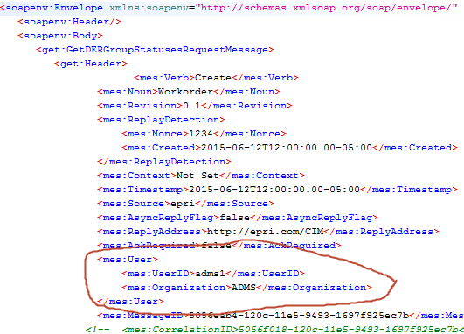

at http://yourserver:3000

Dialog
– adms1 and adms2. Similarly, ExecuteDERGoupDispatches is also defined for vendor ADMS, for users adms1 and adms2
ils of the vendor_test_sequence, see the figure below. Note in the following dialog that you can specify the user id, as well as edit the actual vendor_test_sequence_step record. The red arrow points to the field that is used to specify the XXX_remote_server value, overriding the value that was specified in the application variables dialog, in Figure 5.
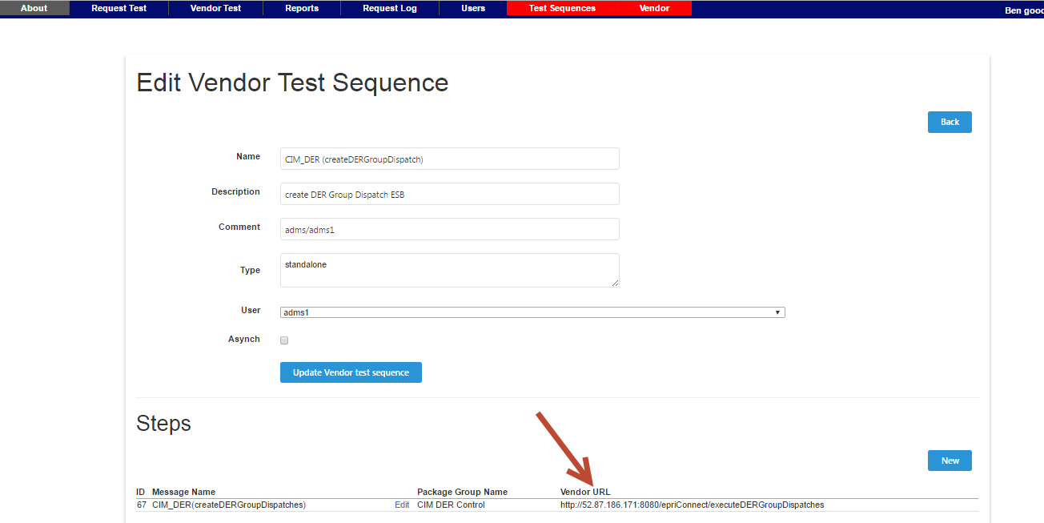

Modify the forwarding endpoint
Now mModify the database configuration to point to the test harness, as if it was vendor 2. In the Mediator Configuration UI, click on Vendor Test, then click the Edit button for the getDERGroupStatuses item, where the comment is adms/adms1(Note that this matches the header value in the message).

SSHing into the server

Glossary
AMI Automatic Metering Infrastructure
CIM Common Information Model
CIS Customer Information System
COTS Commercial off the shelf software
DMS Distribution Management System
DNS Domain Name Service
ESB Enterprise Service Bus
MDMS Meter Data Management

UI User Interface
URL Uniform Resource Locator
WSDL Web Service Definition Language

